**Black Panther Wakanda Forever: The Soundtrack – Artists and their songs**

So, I read another article, this one a Rolling Stone one listing the songs and artists in the Black Panther Wakanda Forever Soundtrack that was released on the 4th of November 2022. I was familiar with some of the artists but not some of them so I thought I’d also make another album track list video focusing on who the 31 artists listed in the soundtrack list. I will make videos for each of the artists if anyone is interested.

Request an artist video if that is the case.

Black Panther Wakanda Forever: The Soundtrack has 19 songs by 31 artists. It blends music from African artists, the African diaspora at large, African American, Native American, Native Mexican, the Caribbean and British artists.

The album starts off with Lift Me Up by Rihanna who needs no introduction and is making a comeback after 6 years of not releasing music. She only appears on 1 song on the album.



Next up we have Love & Loyalty (Believe) by 5 artists DBN Gogo, Sino Msolo, Kamo Mphela, Young Stunna and Busiswa. They are all famous South African artists with huge fans all over the African continent. These 5 appear in 2 songs on the album. Next we see them on track 16 titled Jele (aka Prison).

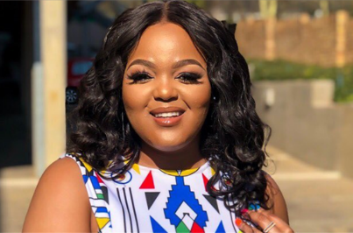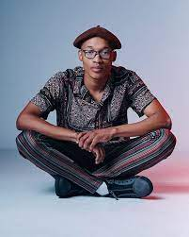

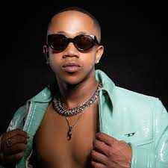

Track #3 is Alone by Burna Boy, the Nigerian artist affectionately known all over the world as the African Giant.

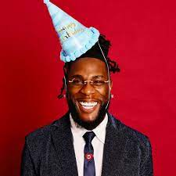

Tems, the British-Nigerian pop star graces track #4 with a haunting cover of Bob Marley’s No Woman No Cry, which we previously heard snippets from the first movie trailer.



Track #5 introduces us to Vivir Quintana a prolific Mexican singer and composer, and Mare Advertencia Lirika, popularly known as Mare, a Zapoteca Mexican singer with the song Árboles Bajo el Mar.

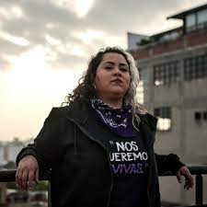 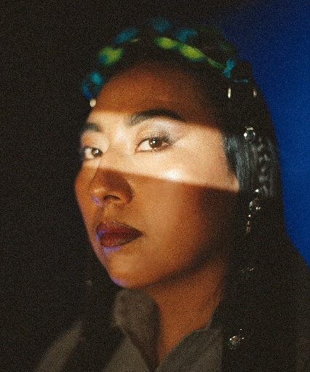

Foudeqush a Mexican singer and Ludwig Göransson a Swedish composer and record producer are up next with the song Con la Brisa at #6.

 

Track 7 is La Vida by Mexican artist Claudia Alexandra Madriz Meza known as Snow tha Product featuring Earl Tywone Stevens Sr the American rapper known as E-40. 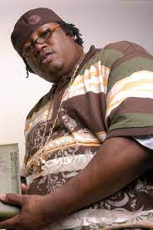

Stormzy, whose full name is Michael Ebenezer Kwadjo Omari Owuo Jr, the prolific British rapper who provides us with Interlude for Track 8.

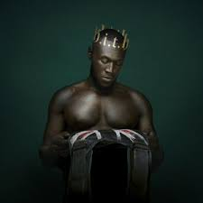

For track #9 we have popular Nigerian singer Adedamola Adefolahan also known as Fireboy DML with the song Coming Back for You.

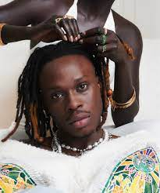

Tobechukwu Dubem "Tobe" Nwigwe is a Nigerian-American rapper from Texas alongside with his wife Fat Nwigwe a duo who gives us the 10th track They Want It, but No Performed.



Track #11 is Laayli’ kuxa’ano’one by ADN Maya Colectivo is a collective made up of young people from the central Mayan area of ​​the state of Quintana Roo. The collective was created by Jesús Pat Chablé, commonly known by his stage name Pat Boy Rap Maya or Pat Boy, Tania Jimenez Balam. Yaalen K’uj, and All Mayan Winik.

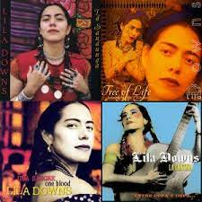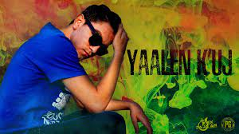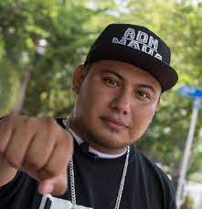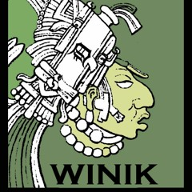

OG Dayv formerly known as White Dave and Future an American rapper collaborate for the 12th song Limoncello.

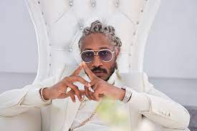

Chukwuka Ekweani aka Ckay a Nigerian singer-song writer are up next with the song Anya Mmiri ft. PinkPantheress a British singer-songwriter and producer.

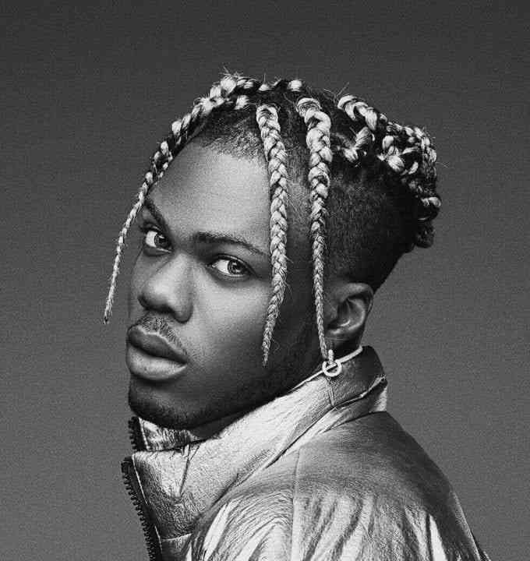

Rema a Nigerian rapper features on two songs on the album. First on Track 14 Wake Up by Bloody Civilian, a Nigerian musician. Then on the song Pantera at #15 by Erick Raúl Alemán Ramírez known as Alemán.

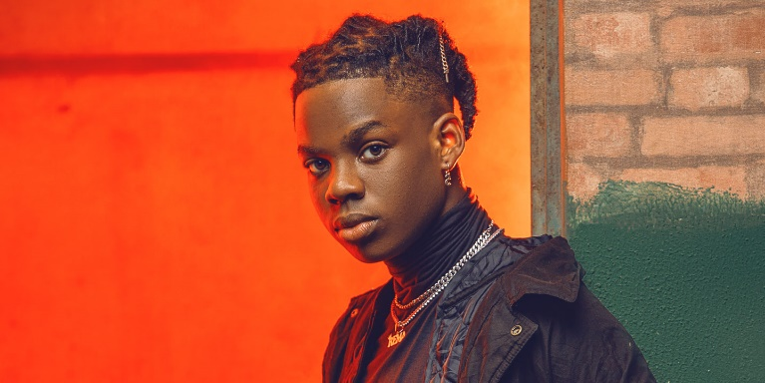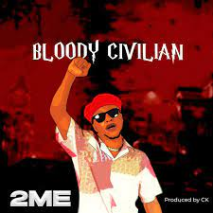

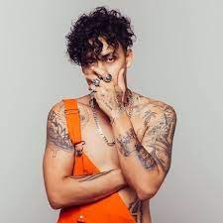

At #17 we have the track Inframundo by Blue Rojo a Mexican pop star.

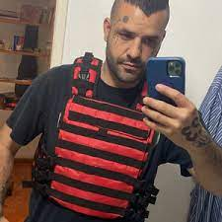

At #18, we have No Digas Mi Nombre by Calle x Vida and Foudeqush a Mexican singer. This is Foudeqush’s second appearance on the album.

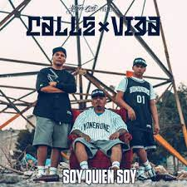

Mi Pueblo is track #19, by Guadalupe de Jesús Chan Poot.